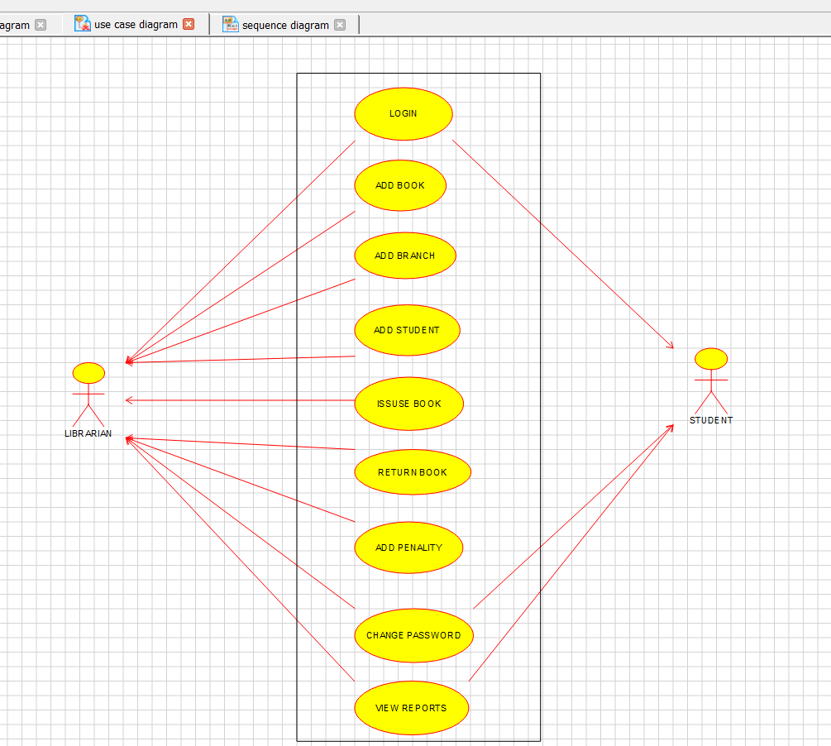

**CLASS DIAGRAM:**

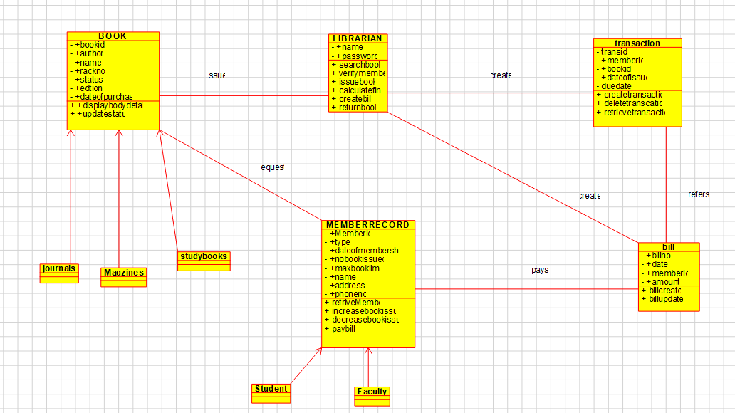

**SEQUENCE DIAGRAM:**

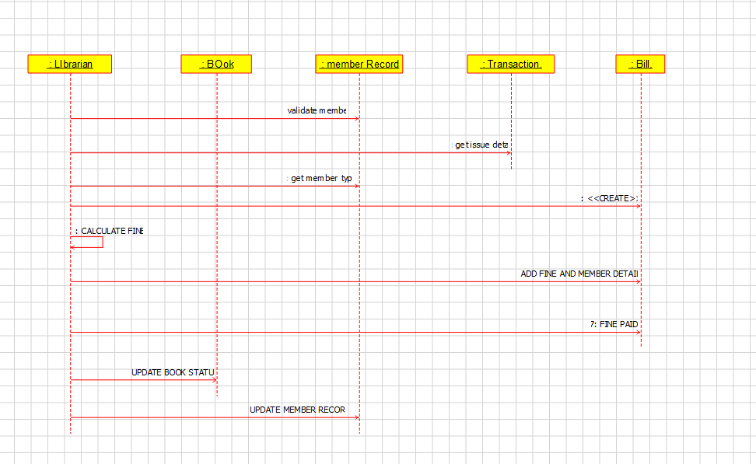

## ACTIVITY DIAGRAM:

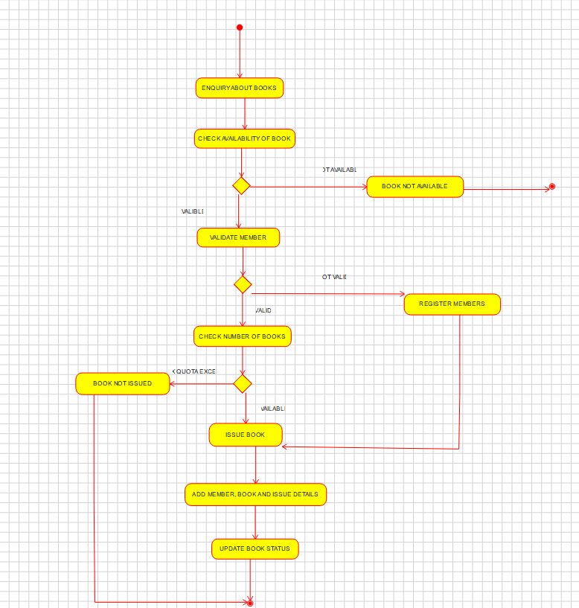

## RESULT:

Hence, the use-case diagram for online voting system is drawn and verified successfully.